4 May 2018
The Rt Hon Jeremy Hunt MP
Secretary of State for Health and Social Care
Department of Health
Richmond House
79 Whitehall
London, SW1A 2NS

(copy to: The Rt Hon Boris Johnson MP,
Secretary of State for Foreign and Commonwealth Affairs;
The Rt Hon Penny Mordaunt MP,
Secretary of State for International Development)

Dear Secretary of State,

Taiwan and the World Health Assembly

I write on behalf of the United Reformed Church, a fellowship of over a thousand local churches throughout Great Britain. We have long-standing and close links with Christian friends in Taiwan, chiefly in the Presbyterian Church there, and have recently heard of their concern about ways that their independent island nation is being marginalised in international organisations and meetings.

The most immediate of these is the World Health Assembly in about a fortnight’s time.

We know that there are strong political feelings in various quarters about Taiwan’s place in the family of nations. However, health ought to transcend politics. Including everyone in an international gathering of this kind is an expression of our common humanity, and a contribution to health and well-being across the world. Disease does not respect our boundaries. Excluding the doctors of any land from such a widespread sharing of wisdom and current concern about treatment, prevention and hygiene affects not only the land excluded but indirectly endangers us all.

The UK is a big contributor to the WHO, and that is a cause for pride. It is also a position of influence. We respectfully ask you to press for the inclusion of Taiwan in the Assembly, as it was from 2009 to 2016.

Yours sincerely,

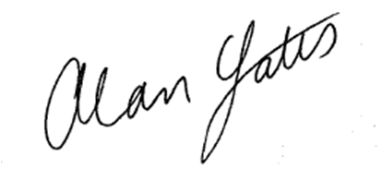

Alan Yates
Moderator of General Assembly

