Called to be a Church for all
Assembly liturgy regarding people with disabilities

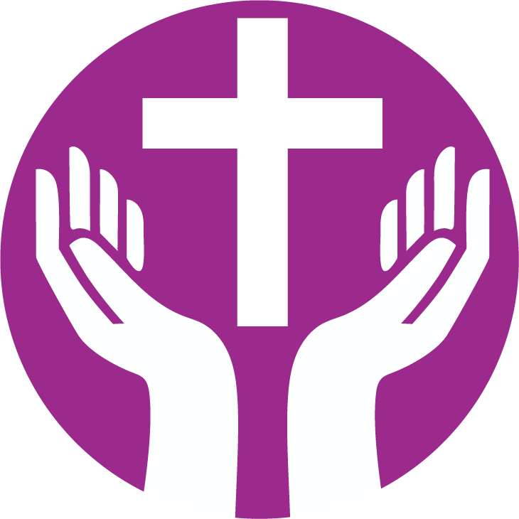
UCA Assembly

Transforming Worship Circle

CALLED TO BE A CHURCH FOR ALL
Accompanying Notes
In the ecumenical document Gift of Being – Called to be a Church of all and for all, a powerful image is Paul’s message to the Ephesians that Christ has come to tear down the walls that separate us (Ephesians 2:14). Although people living with impairment are today less likely to be segregated behind walls, the walls of fear and prejudice remain, including within the church.1
1 World Council of Churches, Para 37, Document No. GEN PRO 06 rev, 2016. https://www.oikoumene.org/en/resources/documents/central-committee/2016/the-gift-of-being
People labelled with disability continue to be under-represented in faith communities across the Uniting Church in Australia, giving rise to questions of why that is so and how it might be addressed. The church is poorer as a result, and in need of a ‘theology of access’ in which the diverse gifts of its members are used for the building up of the whole’ (Basis of Union para 3).
In light of this, in 2018 the 15th Assembly of the Uniting Church in Australia affirmed that:
a. Christ is most fully present when all people in the Body are unconditionally accepted as people of worth. All people are created in the image of God, including people with disability;
b. along with all members, the faith, gifts, hopes and dreams of people with disability are to be valued and honoured; and
c. God is a God of justice and peace, who seeks reconciliation amongst all people.

In seeking to be a community of reconciliation, the Uniting Church acknowledges that for many people with disability its life and faith has not always borne witness to this vision.
The Uniting Church seeks:
a. to embody a community life that in its theology and practice is accessible to all people;
b. to ensure that within its own life people with disability are treated justly and have their hopes and rights realised; and
c. to advocate for justice and equality for people with disability in the wider community.

Assembly also requested the development of an appropriate liturgical response which acknowledges the historical exclusion experienced by many people with disability.
In response, this liturgy has been developed to both lament the absence and celebrate the presence of people labelled by disability, and is designed to acknowledge people’s experiences of exclusion and embrace.
Titled ‘Called to be a Church for all’, the suggestions within provide the materials and information for a stand-alone Service of Worship. One suggestion is that the liturgy be used during the first week of Advent when the International Day of People with Disability is held on 3 December. Alternatively, some components may be incorporated as part of a liturgy/ritual appropriate to your circumstances.
It is important to remember that people’s experience of faith and worship is enhanced by a range of senses as well as by words spoken or written.
Whilst the use of gesture (Auslan signing) is an example of this, in the event deaf people are regular attendees, consideration needs to be given to the whole service being signed.
In planning such a service it is strongly recommended that people directly affected (including families, carers) be consulted and invited to participate in both preparation and leadership.
ORDER OF SERVICE
We begin…
The worship leader begins with the three gestures, repeated once or twice, before speaking the introductory words…. Then demonstrate and teach to invite all to sign.
We begin…this worship with a sign of welcome recognising that not all of us have full hearing.
I will now lead you in the invitation to worship with three simple gestures which come to us from the Auslan community:
Welcome to this service
(repeat after me)
Welcome to this service

Watch the video: https://youtu.be/7IP4S4HrzA0
OPENING PRAYER
(Alternative Traditional offering Uniting in Worship 2, pg 22)
God be with you
And also with you
God of steadfast love,
like the parent waiting, with arms outstretched, ready to embrace the wandering child
God like the shepherd searching for the lost sheep
God like the mother hen gathering her family
You have called us here
No one is lost
No one is left behind
All are welcomed.
Let us join with you
In your fierce joy
Which finds grace in every child of earth
and makes a community open to all.
We ask this in the name of Jesus the Christ
Amen.
CONFESSION AND FORGIVENESS
God who made home within us and amongst us,
Who came to us incarnate as the Word made flesh,
Who knows the pain and joy of being in a body,
You are tireless in seeking out the lost amongst us;
As a church we have not welcomed many of your people.
We have institutionalised,
We have isolated,
We have ignored and we have betrayed,
We are sorry.
Forgive us,
when our faith has been small, and when our welcome has been thin.
Generous God,
Share mercy with us.
Generous God, You do not give up on a single one,
We give up even on ourselves.
Share grace with us.
Generous God,
We gather here in all our brokenness, body, soul and mind,
We admit that by our lack of welcome we have wounded others.
We confess, especially that by our actions of exclusion we have wounded ourselves and wounded our world.
silence
Hear Christ’s word of love to us all!
Your sins are forgiven,
Thanks be to God!
With God’s help we will seek to end exclusion,
and we commit to work for healing in this place.
With the inspiration of the Holy Spirit we will renew our church.
So let us share a sign of God’s peace as a symbol of our commitment to healing and justice.
THE PASSING OF THE PEACE
Noting there may be differing levels of ability and sensory experience, think about how this can be an inclusive gesture
SONG
READINGS
JOHN 9:1-41 (New International Version) with a particular focus on 9:1-3
Healing of the man born blind:
As he went along, he saw a man blind from birth.
His disciples asked him, “Rabbi, who sinned, this man or his parents, that he was born blind?” “Neither this man nor his parents sinned,” said Jesus.
ISAIAH 61:1-5 (Good News Translation)
The Sovereign LORD has filled me with his Spirit.
God has chosen me and sent me
To bring good news to the poor,
To heal the broken-hearted,
To announce release to captives
And freedom to those in prison.
God has sent me to proclaim
That the time has come
When the LORD will save his people
And defeat their enemies.
God has sent me to comfort all who mourn,
To give to those who mourn in Zion
Joy and gladness instead of grief,
A song of praise instead of sorrow.
They will be like trees
That God has planted.
They will all do what is right,
And God will be praised for what God has done.
They will rebuild cities that have long been in ruins.
My people, foreigners will serve you.
They will take care of your flocks
And farm your land and tend your vineyards.
ST. JULIAN OF NORWICH
I saw that God is everything which is good, and encouraging. God is our clothing that wraps and encloses us and so never leaves us.
God showed me something small, no bigger than a hazelnut, lying in the palm of my hand...I looked at it with my eye of understanding and asked myself what is this...In this little thing and I was answered ‘It is everything that was created’.
And I saw three things: The first is that God made it, the second is that God loves it, the third is that God preserves it. But what did I see in it? It is that God is the creator and protector and the lover.
REFLECTION THEMES
Inclusion, exclusion, traditional understandings of suffering and otherness compared to now, what it means to repent and be forgiven, on exclusion as sin etc.
SONG
RITUAL ACTION
Throughout the Bible, anointing with oil symbolises consecration to God
(as in Exodus 28:41, Luke 4:18, Acts 4:27, 10:38 Corinthians 1:21)
The act of anointing is a “means of grace,” which accompanies prayer as a symbol of God’s blessing and connection with us. It is a physical act which helps us to remember, in our bodies, that we are children of God. It can also serve as a reminder of our baptism in which we are ‘anointed’ with water.
The Minister and elders can make the sign of the cross on a hand with olive oil or people can be invited to pass around a bowl and anoint the person sitting next to them.Page 6
PRAYER
We thank you, Holy God,
For being a fool in the eyes of the world.
We thank you for abandoning control,
For creating a universe, new and strange.
We thank you for nurturing life,
Surprising, evolving, diverse and divine.
We thank you for calling a people who did not walk straight or know their limits.
We thank you for different bodies and desires,
For different ways of thinking and speaking,
For different ways of belonging and believing.
We gather on this day and say:
We will not retreat from the world, but will act within it to bring to be the commonwealth of justice, for all of Earth’s peoples, and for the Earth itself.
FINAL BLESSING (Auslan version to be taught with video)

Watch the video: https://youtu.be/9F64KzKEFB0

THE LORD’S PRAYER

Watch the video: https://youtu.be/vc2Zi1i-bWs
SONG SUGGESTIONS
Come as you are (TiS 693)
Tune: Londonderry Air
June Boyce-Tillman
Gather us in (TiS 474)
Marty Haugen
We cannot measure how you heal
John Bell and Graham Maule
I heard the voice of Jesus say (TiS 585)
Horatius Bonar

THANKS TO
The UCA Assembly is grateful to those who have helped draw this material together and have been generous in their time and expertise. In particular to Rev. (Deacon) Andy Calder, Rev. Dr Trevor Whitney, Dr Damian Palmer, Rev. Alex Sangster, Ms Julie Perrin, Ms Susan Stork-Finlay, Ms Christina Rowntree, Rev. Alistair Macrae, Rev. Ian Ferguson and Rev. Prof Stephen Burns. Thanks also to Ramas McRae for our Auslan translations.
The words from the prayers have been inspired by the work of Steven Shakespeare. Steven is Lecturer in Philosophy at Liverpool Hope University. He is the author of Prayers for an Inclusive Church published by Canterbury Press. 8

