ASIA PACIFIC KAIROS: A prophetic call to journey together with the PCT in pursuit of justice and peace for the people of Taiwan and the Asia-Pacific
“What does the Lord require of you but to do justice, and to love kindness, and walk humbly with your God” Micah 6:8

TEF Newsletter Issue 9
Photo of the February 2019 Steering Group Meeting in Berlin, Germany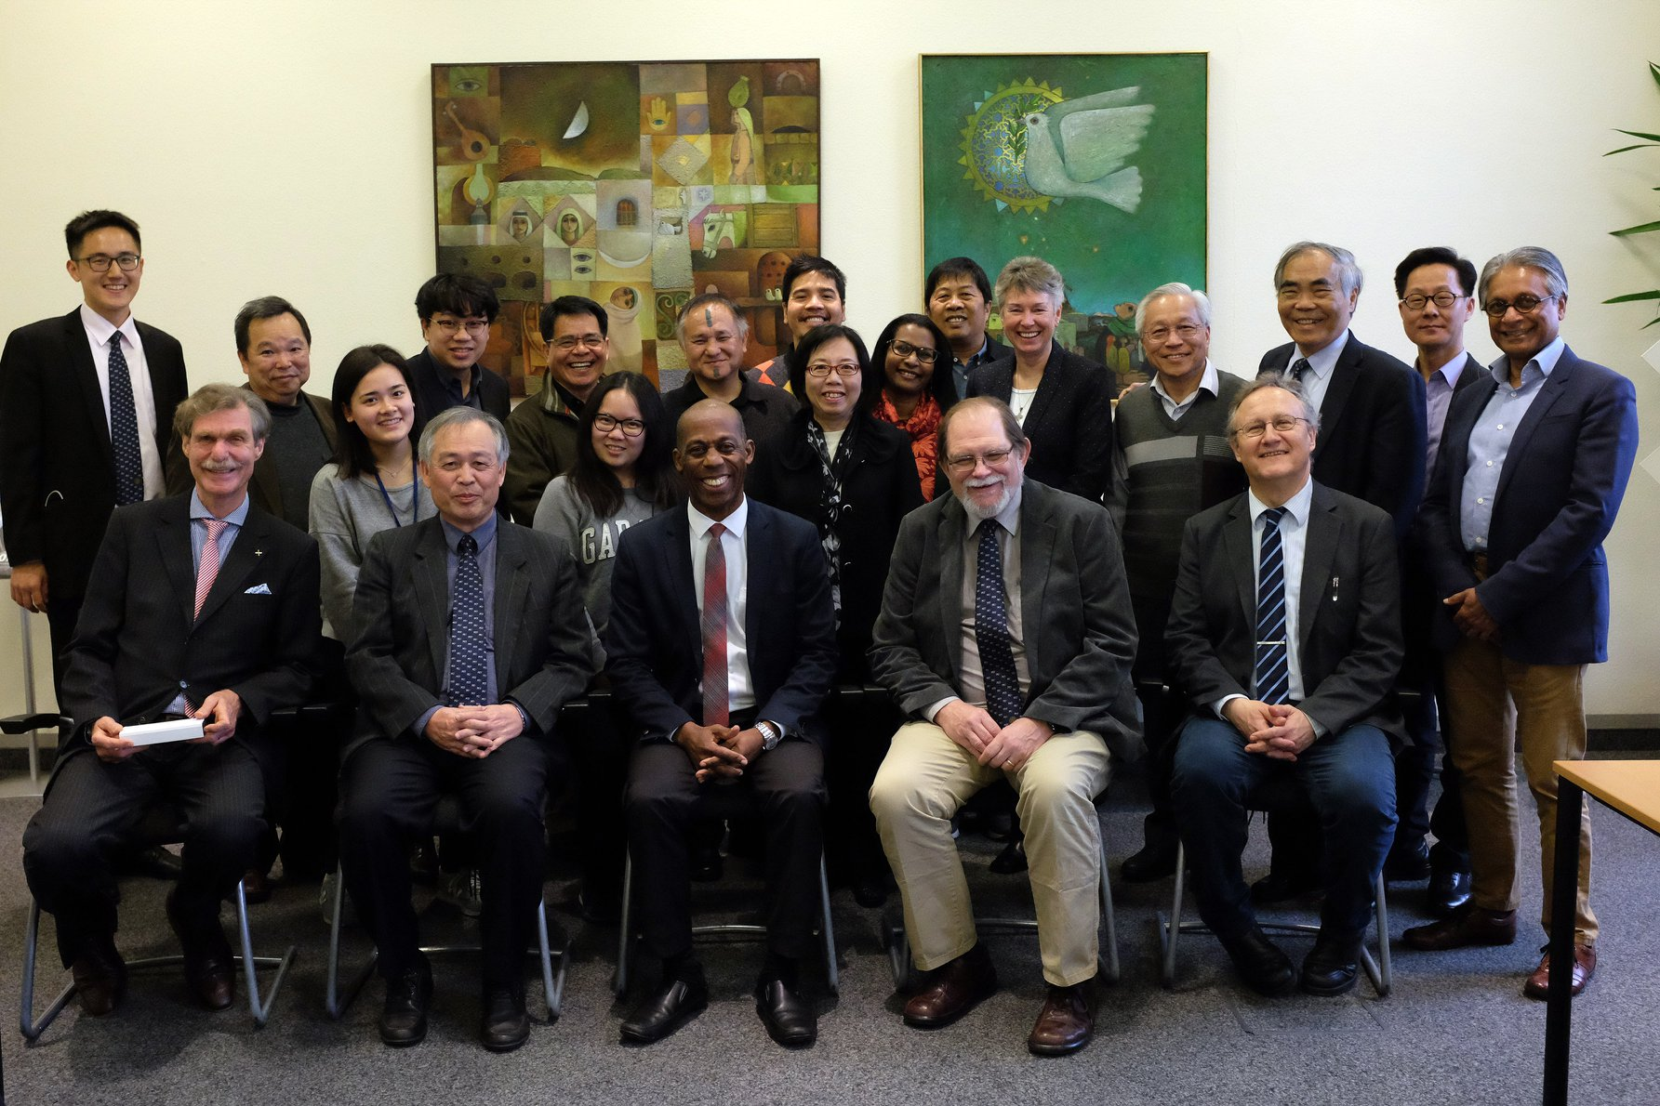

- Video of the November Meeting of the TEF

For the participants and those interested in finding out the highlights of the first TEF meeting in November last year here is the link to the 23-minute video: https://youtu.be/ViT393ADaPA

- Please also be reminded that the TEF has a website:
http://english.pct.org.tw/tef/index.html

- The next meeting of the TEF Steering Group will take place in Taiwan on June 17-18, 2019. On June 19, there will be a joint meeting with the DARE program of the Council for World Mission. DARE will bring about 90 theologians, scholars and ecumenical activists to Taiwan for its 2019 forum.

Below is the program for the joint meeting and a brief introduction to DARE
2019.6.19
Time | Contents | Moderator/Speaker
0800  09:00 | TEF SG members Travel from Howard Civil Service International House Taipei to Chi-Lin Foundation DARE members Travel from Cuncyue Resort to Chi-Lin Foundation, Yi Lan
09:30 | Welcome and Introductions  Welcome :Lyim Hong-Tiong, PCT General Secretary Introduction :Sudipta Singh | Moderator: Li U-Peng, PCT TEF Task Force staff  Greetings :Lim Gi-Hiong (林義雄)
 | Greetings by Founder of the Chi-Lin Foundation
10:00 | Tour Taiwan Democracy Movement Museum | Docents from Chi-Lin Foundation
11:00 | Break
11:30 | Introduction to TEF Taiwan Isolation (Victor Hsu) Next Steps(Collin Cowan/ Chris Ferguson)/ | Moderator: Nancy Lin, PCT Member on TEF SG
12:30 | Lunch
14:00 | Panel on TEF Issues  Speaker: Omi Wilang (IP)  Response From DARE (2-3 persons) | Moderator: Vavauni Ljaljegean PCT TEF Task Force  PCT staff
15:30 | Travel to Lo-Tong church
16:30 | DARE Opening Worship  Preacher: Lyim Hong-Tiong | Liturgist: Dongi Kacaw
17:30 | Travel to Restaurant for Welcome Dinner
18:00 | Welcome Dinner | Moderator: Lian Chin-Siong

Discernment and radical engagement (DARE) are at the heart of the CWM mission. This annual forum provides a platform for scholars and activists to present and challenge perspectives on mainline theological and biblical

scholarships while rooted to ground-level struggles and concerns. At the same time, they are provided the opportunity to share personal insights, viewpoints and experiences through publications – with the end goal of growing and better equipping themselves in discernment and radical engagement with local communities.

Through DARE, CWM partners with committed and creative thinker-practitioners of our time, signaling to ourselves and to the world, that our loyalty is to the God of life who calls us to take on the life-giving mission for which Jesus lived and died.
DARE also comes out of the conviction that another world is possible. Another world free from the politics of hate; ideologies of supremacy; enslavement to the imperial logic; a world in which ecology could heal; security of children is a priority; strangers welcome each other; movement of people is a right and freeing; the elderly is treated with compassion and care.
The forum’s theme this year is organised around six streams:
- Earth
- Class
- Race / Caste
- Gender
- Occupation
- Artificial intelligence

