Moderator of the Presbyterian Church of Taiwan,
Rev. Tan Beng-Chi
and
General Secretary Presbyterian Church of Taiwan,
Rev. Lyim Hong-Tiong

7 February 2018

Greetings from Aotearoa New Zealand,

We awoke today (7 February) to the news of the 6.4 magnitude earthquake in Hualien.

On behalf of our Moderator Right Rev Richard Dawson and the whole PCANZ I write to express our concern, care, love, prayer and support to you, the whole staff and the PCT family. We join together to express our sorrow for the loss of life and join our prayers with many others for those missing and injured together with the many people displaced.

Like you, we understand the power and damage of earthquakes and how they impact the lives of many. We continue to be amazed at the work you do in caring for your communities and the disaster response teams you have to assist. We will be praying for all those involved in rescue work also – especially as you experience after shocks.

Kia kaha is a Māori phrase meaning stay strong, used as an affirmation. It took on special significance following our recent earthquakes. May it have significance for you all as you face the days ahead.

If we can assist – please be in touch.

We deeply value our partnership – and at this time want to ensure you of our on-going care, love and prayer.

Yours in the partnership of the Gospel,

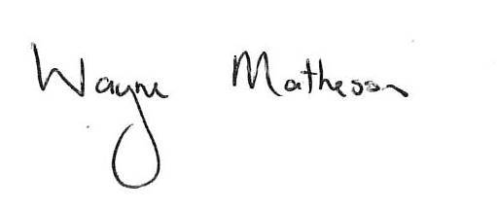
Wayne Matheson

