126 Rosa St, Oatley NSW 2223
In our family, it has been a big year, influenced by the coronavirus both directly and indirectly.
This time last year, Australia had already seen some of the worst bushfires ever experienced, with dirty, smoky air and very low water levels in our dams, which continued through to the first weekend of February 2020. A three-day national deluge of rain, courtesy of a belated Indian Ocean dipole, put out most of the fires and filled the massive water storages around Sydney up to nearly 90% capacity; but also severely damaged the main building of the care home where Grandma Cole was living. We were away at conferences overseas when we heard the news, so we returned home early.
That was just before our government put a biosecurity ban on international travel. We were fortunate to find a new place quite close to where we live. I drove Mum across town, describing places as we drove past. She added her memories of having lived at, or being connected with several places, including the suburb where they lived when I arrived in 1952. Mum settled in well, but with a general ban on family visiting, she lost appetite and slowly faded away, even though we later had special visiting rights. Lindt chocolate was not a temptation in her last week, and she left us on Ascension Day Thursday morning May 21st, aged 98½, an accidental victim of coronavirus precautions. We were able to arrange a small COVID-safe family memorial service on June 5th, a sunny winter day, at St Marys Denham Court, and we interred Mum’s ashes together with Dad’s remains in the family tomb. Celebration of 50 years, back in Sept 2001 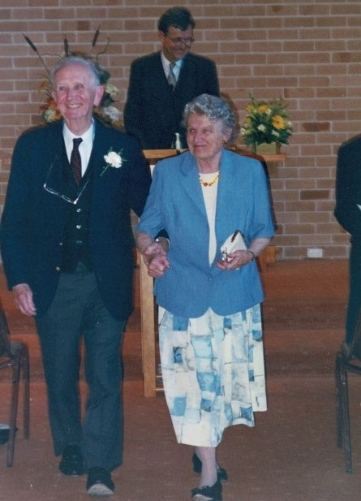

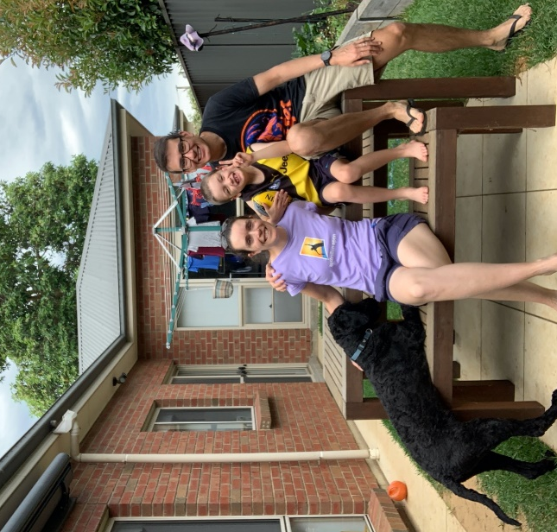 Wallace, Bec, Josh & Scott at home. Bec and Scott had an exciting start to 2020 with a trip to the Australian Open with old friends from Wagga. We also acquired a fur baby (Wallace, a black groodle puppy), and Josh started school. We’ve both continued in our health jobs and despite the limitations of the year we’ve enjoyed a pretty normal life in Adelaide for most of the year (until recently). We’ve done lots of local camping and Josh has become the reigning family UNO champion. We’ve enjoyed trying new recipes and have finally nailed homemade pizza and sourdough fruit loaf. Josh particularly enjoyed the 2020 AFL football season this year and has adopted the Richmond Tigers as his team.

The moto for 2020 is, when life gives you lemons, you should probably stop drinking gin, because drinking during a pandemic will make you fat. And quickly. If you want to donate to the Rachel Christmas fund, please send your millions to Pfizer or Moderna, and organize vials of vaccine to be couriered and rapidly given to me.
Let’s put that in the bin and start again, shall we? 2020 started on a high, touring with ‘Billy Elliot’ in Adelaide, and visiting with Bec. The show then moved onto Melbourne, when on 13 March at interval, the cast watched a press conference from the Prime Minister decreeing that all venues over 100-capacity would be shut immediately; an hour later we were told to clear out the theatre. Everyone I know lost their jobs overnight; there was zero financial government support. At that stage, I had already been cast in Opera Australia’s Yiddish version of Fiddler on the Roof (Fidler Afn Dakh) due to open at the Opera House; that too was cancelled. Wanting to make the most of time (Melbourne had the world’s longest and most severe lockdown), I enrolled in a Master of Economics, which I’m loving, and I still work in Property Investment. Flip and I are stoked to move back to Sydney after Christmas, when he’ll start a Bachelor of Psychology at Macquarie Uni, to complement his theatre work in 2021, having won a role in a production of ‘Head over Heels’ in Sydney.
Flip & Rachel 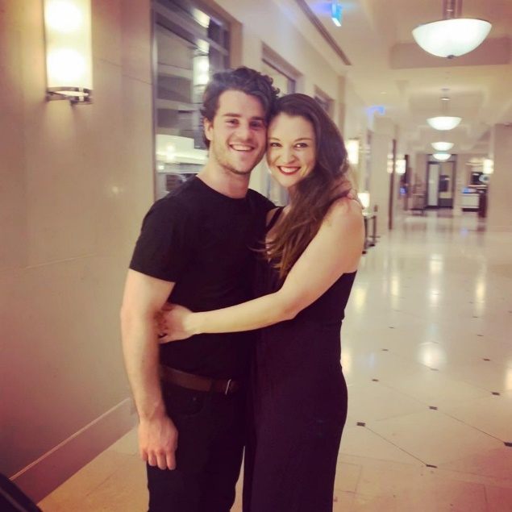

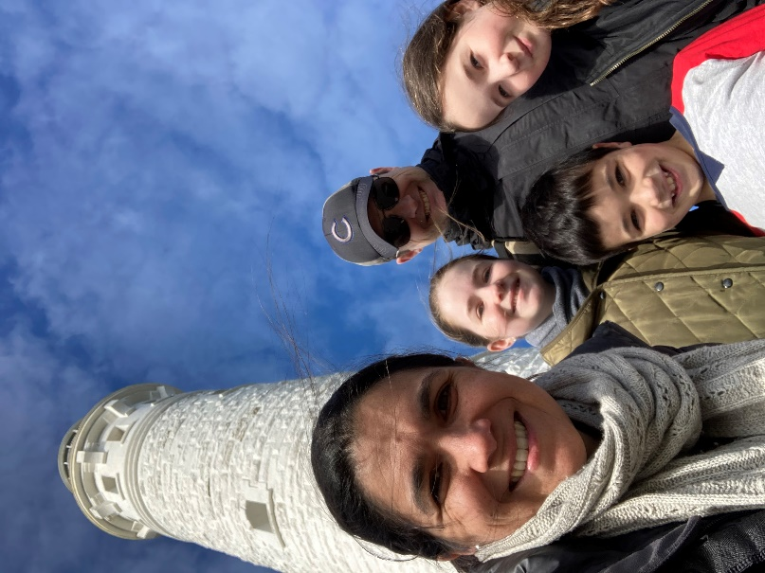Emily, Ashlyn, Hamish, Dan & Rhianna at Cape Leeuwin lighthouse
Living in the world’s most geographically isolated city certainly had its advantages for us in 2020. After a term of online teaching (Dan) and online learning (Ashlyn, Rhianna & Hamish), life has become relatively normal in Perth. Emily has really enjoyed working this year in home-based aged care physiotherapy. Ashlyn (13½) is taller than Emily and has been throwing herself into school and music, and recently sat her 4th grade piano exam. Rhianna (nearly 12) is closing in on Emily fast and has been enjoying life in middle school and has taken up rock climbing. Hamish (9½) continues to enjoy both Aussie Rules football and cricket and has also read the most words in his grade this year by polishing off the Harry Potter series. Dan continues to teach at Trinity Theological College, focusing on Greek and New Testament books, and is looking forward to seeing his dissertation finally being published early in 2021..
This year saw Laura return to work part time at Anglicare as an Out of Home Care Case Manager where she had worked prior to the arrival of the twins. David also started a PhD this year through Macquarie University, studying leadership of school transformation. He has been doing this part time, whilst continuing to teach at Thomas Hassall Anglican College. Their eldest, Timothy, recently turned five and is very excited about starting big school next year and making lots of new friends. Having turned three (below), Emma & Matthew are brimming with words 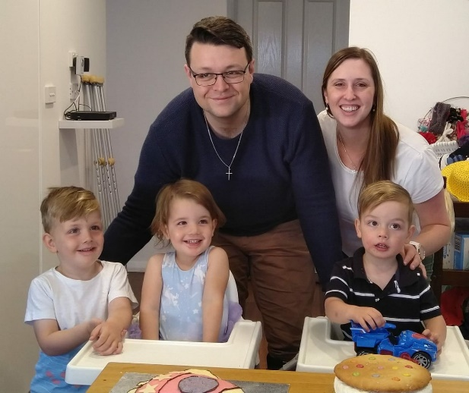 and personality, and love playing with their big brother. The coming year will present a big change for David and Laura, as David has accepted a role as Assistant Principal Teaching and Learning for grades P-12 at St Philip's Christian College in the Hunter Valley at Cessnock, starting in 2021. They moved up to Newcastle in December to settle into life there as a family, before David starts his new role in early January. They are looking forward to living a lot closer to the beach in a much smaller city! Packing the van to leave Glenwood 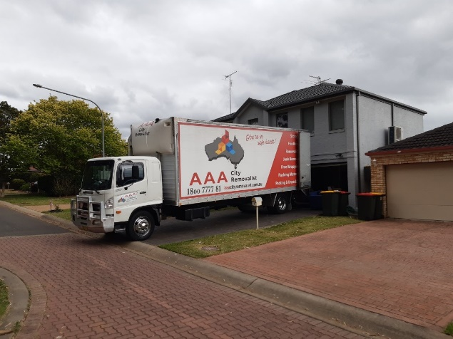

At Oatley, life after March 2020 has been rather quiet. Andrew had an ‘essential worker’ certificate and drove to-and-fro on empty roads, three days a week for his work. Sydney’s air became even cleaner than usual. There were often more people and dogs out walking, than cars driving around.

Most of our HammondCare hospital patients and nursing home residents are very high-risk because of frailty, dementia or cancer, and so we spent a lot of time to make sure that our facilities are safe places for their care. When COVID gets into a place where groups of older people are together, the effects can be quite catastrophic, and it usually comes in on the hands and faces of workers, or of visiting family members. Most other places banned visitors (although HammondCare did not), running the risk of an older person developing depression or confusion when family cannot visit. To prevent that, all our staff had to be scrupulous about washing hands, wearing masks and gloves, and being careful about 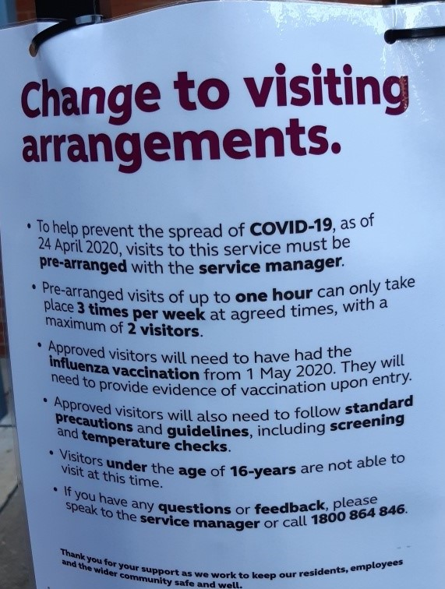 keeping to ‘safe living bubbles’ after hours.

Thankfully, only a couple of our HammondCare nursing home residents returned positive COVID swabs this year, and we were able to provide each one with individual nurses and personal care packages into their single bedrooms, and all recovered completely. Not one of our staff became infected throughout the whole eight-month period that our health and aged care systems were on orange or red alert. This was especially difficult in providing care for some hospital patients in our Palliative Care units, in their last days on earth, with family visiting allowed through compassionate quarantine exemptions, for relatives coming from the UK, USA, Canada, Hong Kong, Singapore and China, quite apart from folk coming from other states in Australia, across otherwise-closed borders.
Marilyn has been working mostly from home since mid-2016, so the changes due to COVID affected her a little less, relatively speaking. Some EdComm events went on Zoom but unfortunately our big events (the annual conference & dinner) were cancelled. She continued to develop NESA accredited online teacher Professional Development courses for the events that could run and complemented this with a longer course ‘Surviving and Thriving in the New Normal.’ She also wrote blogs for each of the eight modules of this course and an accompanying e-book which is published on the EdComm website. She learnt new skills in publishing, using Doodle (lots of fun) and filming to enliven this course! For a time, Bible study and Physie (physical culture) were on also Zoom. Learning a Physie routine with the help of Belle the dog and intermittent internet was sometimes a challenge but a little more real than learning Physie outdoors and wearing joggers on the oval! Fortunately, all went back to ‘new normal’ so we could train for the annual competitions in a hall after October.

Mr Bartley’s Burgers, Boston 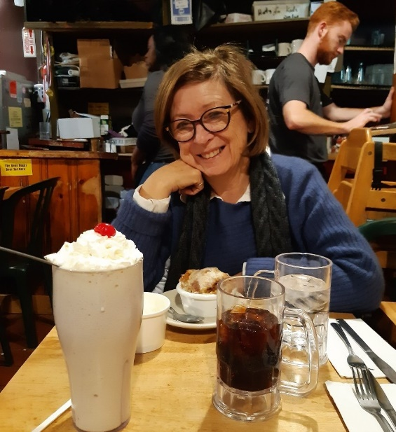
Bushwalking at Port Macquarie
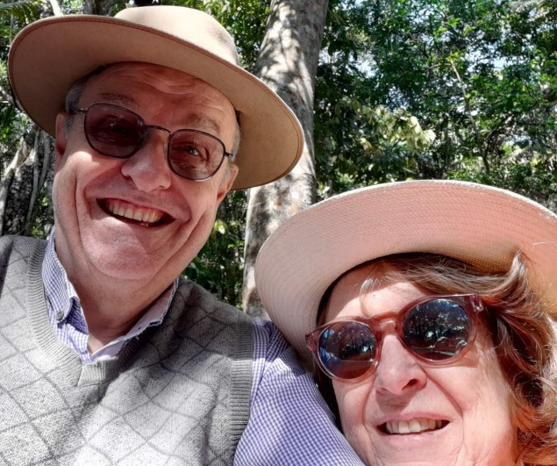
With work being busy this last year, the chance to attend simultaneous Harvard geriatric medicine and school education professional development conferences in February, on opposite sides of Boston, was wonderful. We had two short breaks in the July and October school holidays, going to the Tweed Valley and Port Macquarie on the NSW North Coast, as travel outside our state borders for much of the year was not possible.
Our church building was closed for a planned major refurbishment (the first one since it was built, between 60 – 75 years ago), around the same time that all NSW churches were closed due to COVID and moved into Zoom format for meetings great and small. Not very much organ-playing this year, sadly! The builders had finished their work in our church by early November, and we were permitted to resume face-to-face services in NSW, from just a couple of weeks later.

