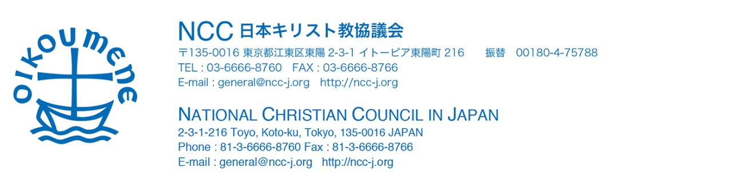

Dear Rev. Lyim Hong-Tiong,
The Presbyterian Church in Taiwan

February 10, 2016

We pray for the victims and suffering people cause of the earthquake in Taiwan in the name of Jesus Christ.

Contribution from National Christian Council in Japan
￥100,000

Rev. Koichi KOBASHI
Moderator
National Christian Council in Japan

