28 March 2014

The Moderator and General Secretary of the Presbyterian Church in Taiwan

(Via email: gs@mail.pct.org.tw)

Dear Rev. HSU Rong-Feng and Rev. Lyim Hong-Tiong,

We have received with deep concern your ‘Affirmation and Appeal’ dated 22 March 2014. We write on behalf of the General Assembly of the United Reformed Church to offer our support and encouragement. We pledge to stand with you as partners in Christ’s mission of justice and peace. The right to peaceful protest is a cornerstone of democracy and we call upon the Government of Taiwan to listen to the voice of their own people.

When a majority uses violent force to silence those who oppose them then the people of God must raise their voice and stand with the oppressed. Your sisters and brothers in Christ within the United Reformed Church pray that you will be granted the courage and strength to stand firm in these difficult times. We affirm you in your determination to uphold the declaration of faith that “the church is called through love and suffering to become a sign of hope.”

May the bonds of love and fellowship established between us assure you that you do not stand alone in your fight to protect democracy and transparent government in Taiwan.

In the name of Christ the peace giver and friend of the oppressed.

Yours sincerely

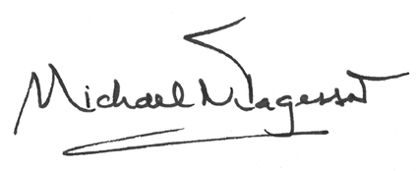

Revd Dr Michael Jagessar Mr John Ellis

Moderator Moderator