I Love Taiwan Mission Camp 2018

Aims
Training in Mission: We expect the youths to experience God’s grace and love, to learn and live out their faith, and to be challenged to devote their lives to God through the participation in missions. Also, we hope, through this camp, the youths will be willing to be involved in ecumenical movement and construct a life of identification, devotion and growth.

Objectives
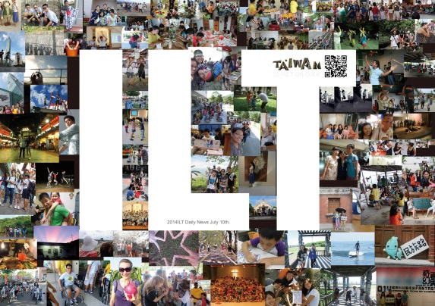
- Widen overseas youth’s knowledge and understanding about people and the churches in Taiwan through mission involvement (e.g. teaching English in summer camp) in cross cultural and multi-religious context.
- Develop a network among overseas youth, Taiwanese youth and churches.
- Cultivate leaders through participation in community mission and evangelism.
- Motivate ecumenical involvement in local churches.
- Dates July 4 to July 21,2018
- Application deadline April 30, 2018(Monday)

Program Outline /Venue
Date | Venue | Program | Content
July 4 | Taiwan Taoyuan International Airport(TPE) | Arrivals | Overseas youths’ arrival in Taiwan
July 5 - 7 | Presbyterian Bible College | Orientation | - Preparation and program introduction  - Get to know Taiwan and the Presbyterian Church  in Taiwan(PCT)  - Get familiar with Taiwanese local youths
＊Address: No.56, Gaofeng Rd., East Dist., Hsinchu City 300, Taiwan
（新竹市高峰路56號） ＊Tel:+886-3-521-7125
July 7 - 18 | Local Churches in Taiwan | Church Mission | - Participate in community services in organizations or churches  - The target groups -- children and teenagers  - Join one-day tour
 | Local Churches/Organizations in Taiwan
July 18 - 21 | William-Sia Memorial Camp | Debriefing | - Group sharing and report writing  - Program reviews and suggestions  - Culture Night
＊Add: No.25, Liyu Rd., Puli Township, Nantou County 545, Taiwan（南投縣埔里鎮鯉魚路25號）
＊Tel: +886-49-2992352 ＊Website:http://www.facebook.com/XieWeiJiNianYingDe
July21 | Taiwan Taoyuan InternationalAirport(TPE)* | Departure | Overseas youth depart from Taiwan
- Language Translation between English and Taiwanese or Mandarin.

Role of Host Churches/ Organizations Taiwan
- Initiate summer mission programs.
- Support overseas youths’ local expenses, accommodation and one day tour.
- Recruit at least 2 local youths to participate in this program and send their applications with church/organization’s application forms.

Who may Participate?
- Youth sand young adults from overseas. (Age16-35)
- Youth sand young adults who are interested in cross cultural mission.
- Youth sand young adults who are willing to cooperate with local church/organization’s summer program.
- Youth sand young adults who want to know more about Taiwan.

Expenses
- Local expenses, during June28 – July 15, will be fully supported by PCT, local host churches and organizations. The expenses Includes food, accommodation, accident insurance, transportation and exposure program.
- Participants will be responsible for all other expenses: International air fare and other expenses in Taiwan, e.g.Laundry, telephone, medical insurance, and extended travel in Taiwan, etc.

How to Register
- If you apply through post or fax, please type or write your form clearly in capital letter.
- You can also apply through internet. The procedures are as follows: Go to PCT youth Ministry website(youth.pct.org.tw),download the application form, fill in your information, and send your application to: youth@mail.pct.org.tw

Program Contact Person
The Youth Ministry Committee of the Presbyterian Church in Taiwan(PCT)
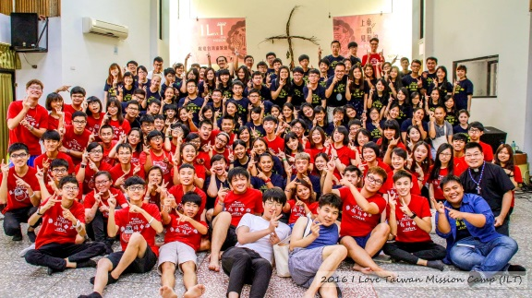
Program Secretary: Rev. LEE,HSIN-JEN
Program Assistant: Ms. Lan, Yu-Ching (EMMA)
TEL:+886-2-23625282ext.610
Fax:+886-2-23631722
Address: 3, Lane 269, Roosevelt Rd. Sec.3, Taipei, 10647 Taiwan
E-mailAddress:youth@mail.pct.org.tw
Website:youth.pct.org.tw
Support us
Youmight have heard of or participated in “I Love Taiwan Mission Camp(ILT).”The overseas participants will
serveindifferenttypesoflocalchurchesinTaiwansuchasindigenous,urbanorruralchurches.
Some of these churches lack funds and coworkers to carry out the mission tasks. We, therefore,welcome your prayer andsupport.
“I Love TaiwanMission Camp(ILT)”welcomes special donations for these churches and organizations in need.
Donations willbe forwardedto PCT YouthMinistry Committee. Your support will be highly appreciated.
Bank details are asfollows:
DIRECT DEPOSIT AND WIRETRANSFOR
◆ ALL FOREIGN CURRENCY：
AccountNo.： | 013002802087242539 | SWIFT：UWCBTWTP
AccountName： | Juridical Person of Mission Foundation of the Presbyterian Church in Taiwan
Bank： | Cathay United Bank
 | No. 149, Sec. 3, Roosevelt Rd., Taipei, TAIWAN
※PleasenotifyPCTwhendeposit/transferismadeindicatingpurpose (2018ILT)ofpayment,contactnameandaddress.

◎ Contributions towards I Love TaiwanMission
You might have heard of or participated in “I Love Taiwan Mission Camp”. The overseas participants will
serveindifferenttypesoflocalchurchesinTaiwansuchasindigenous,urbanorruralchurches.
Some of these churches lack funds and coworkers to carry out the mission tasks. We, therefore, welcome your prayer andsupport.
Special donations to assist these churches organize “I Love Taiwan Mission” camp are welcome.
Contributions may be sent to PCT youth or by direct transfer. (Bank details below) Thank you for sharing with us in mission. With bestwishes,
DIRECT DEPOSIT AND WIRETRANSFER：
※PleasenotifyPCTwhendeposit/transferismadeindicatingpurpose (2016ILT)ofpayment,contactname
andaddress.

